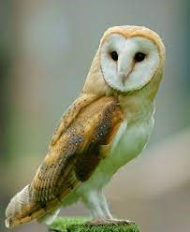

EYFS Visit from some Birds of Prey

Thursday 28th September 2023

Dear Parents/Carers,

We have a fantastic opportunity for our Nursery and Reception children this Autumn.

As part of De Lacy’s 50 things to experience in EYFS, we are hoping to have a visit to school from some birds of prey.

We have had this pleasure in previous years and the children have thoroughly enjoyed it!

The visit will be on:

Friday 27th October 2023

To cover the cost of this visit we are asking for a contribution of £2.00, to be paid via MCAS. School have subsidised this to help with the cost.

We are looking forward to our exciting experience. Thank you once again for your continued help and support.

